Meta Title: Get Consultancy for Islamic Finance Company | Reach out today!
Meta Description: We provide sound consultancy to any and every Islamic Finance Company. If you want Shariah-compliant finance structuring solution, call us right away.

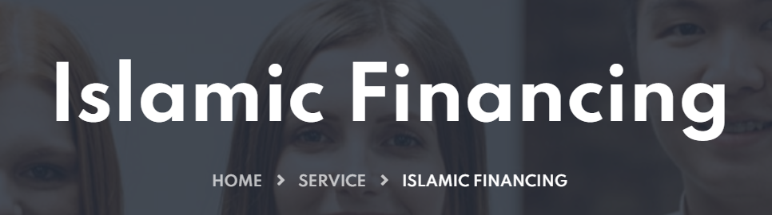

Need Consultancy for an Islamic Finance Company?
At The Neo Consultancy, we are empowering Islamic finances. You can think of us as your one-stop solution providers when it comes to Islamic Finance Consultancy for any and every Islamic Finance Company. With our holistic and cutting-edge advisory, you can manage your finances in an Islamic way.
Call us today!

What are Islamic Finances?
When you manage your money in a way that it stays within the moral principles of Islam, it is called “Islamic Finances.” Another name for these is “Shariah-Compliant Finances.” Moreover, you should know that it covers the following aspects of finances:
- Savings
- Investments
- Debts
- Purchases
If you want to know more or have any concerns or queries, feel free to contact us. We are always ready to guide you. Get in touch right away.

We offer best Islamic Financial Consulting for Businesses
We have broad and extensive know-how that helps us provide valuable and distinctive consultancy. Unlike any other Islamic Finance Company, we offer you end-to-end Shariah solutions. After all, our vision is to support the growth of Islamic finance industry with right advisory. You can reach out to us for consultancy if you belong to:
Government Bodies | Stock Markets | Sukuk and Bonds
Banking | Investment Funds | Insurance Companies
Islamic FinTech | Finance Industries | Training and Development

Islamic Finance Consultants your Islamic Finance Company needs!
From us, you get the best Shariah advisory solutions. After all, we are the leading Islamic Finance consultants who are knowledgeable and aware of Islamic values and ongoing baking and finance trends. You can count on us for valuable and distinctive Shariah advisory services. If you are a stakeholder who wants to implement Shariah compliance in their Islamic Finance company, we can assist you with the right consultancy.

Islamic Finance is not your usual Finance type!
The core belief of Islamic finances is that the money should not have any value in itself. Therefore, it becomes a way to exchange products and services that DO have value. By keeping your focus on this, in Islamic Finances, you do not make money from money. This means that wherever possible, getting involved in interest by either paying or receiving it should be avoided. What’s more, Islamic Finances should not cause harm. Therefore, you cannot invest in things like alcohol, tobacco, and gambling when you are Shariah Compliant.

Islamic Financing is not only for Muslims!
That’s right! Anyone can use Islamic Finance services and products – don’t necessarily have to be Muslim. And our consultancy is also available to all. If you think you share the core values of Islamic financing, then you should switch your company to Islamic finance company. And on this, we can offer you the sound consultancy you need.

Why Choose The Neo Consultancy?
Not only do we provide the best Islamic Finance solutions, but we also have many conventional banks in our network that have had success in the Islamic arena. We help them leverage their position rather than dilute their strength. Over the years, we have dealt with a high number of conservative clients. So, our exposure to the Islamic Finance sector is very helpful. We can easily provide Shariah-compliant finance solutions across all business lines.

We can fully guide you on Islamic Finances!
When you get a Shariah-Compliant financing structure, you don’t pay interest. Instead, in return for having ready access to your money, the deposit you give the bank is used as an interest-free loan. You call this loan ‘Qard.” For savings, the bank or company doesn’t invest your money that is harmful by the Shariah terms. And the return you get is called “Wakalah.” It depends on what you invest in and how the profit works. For purchasing, there are alternatives to traditional mortgages. In all the cases of Islamic Financing, you need a sound guide by your side. And this sound guide is The Neo Consultancy. So, let us help you. Get in touch for our Islamic financing consulting services. We are always happy to help you.

